China high quality standard golf grip
1.Larger Lower Hand
2.All-Weather Control
3.Maximum Surface Texture
​
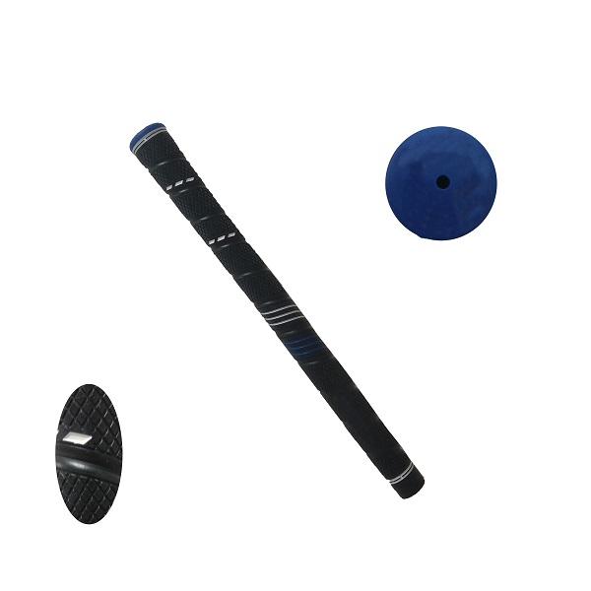
More information please click： www.tt-golf.com

